Day 44

DIY Questions:

Mike works in an organization and is assigned to work on git. Consider a scenario where he creates a folder in his working directory, checks all the configurations made on git, and then deletes the created configurations. Perform the following tasks to validate the given scenario.

Tasks:

1.Install git on your machine

2.Create a working directory

3.Initiate git in the working directory

4.Check the creation of the .git folder

5.Execute the git configuration command to set the username and email of the git repository as global

6.Check the global level configurations in the config file

7.Execute the git command to list all the git configurations set on the repository

8.Now delete the entry of created configurations

Soluton:

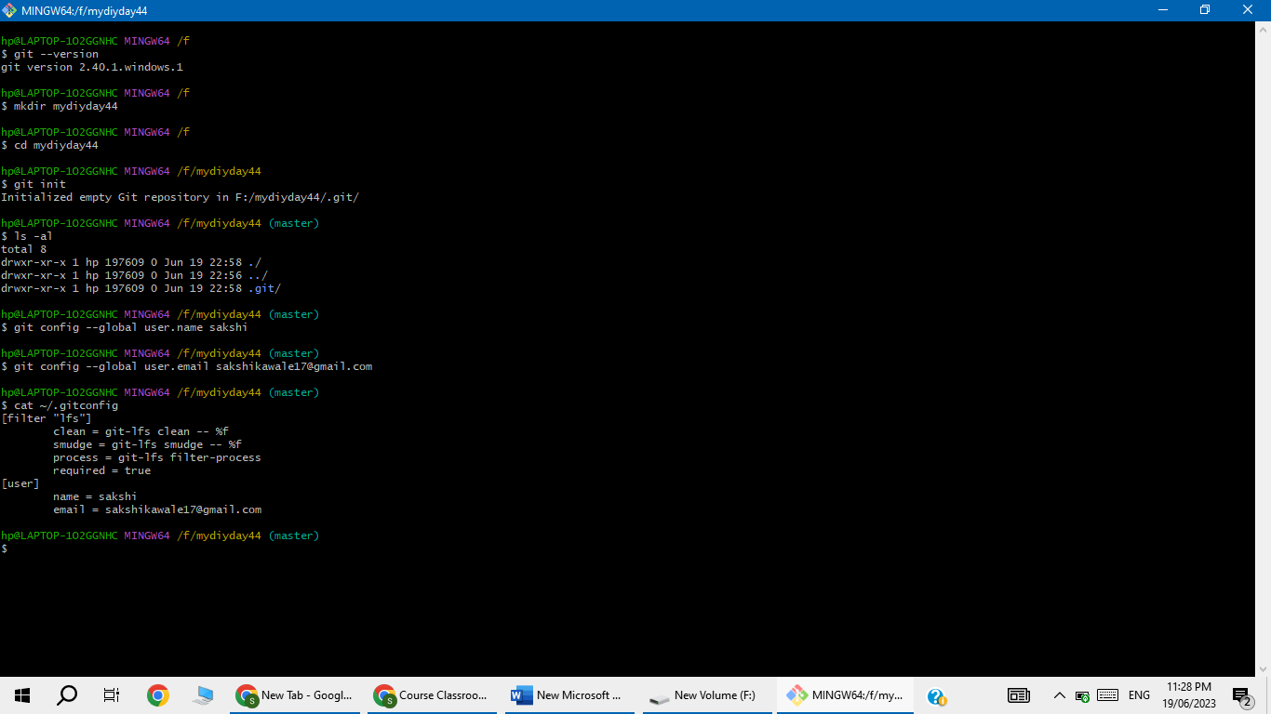

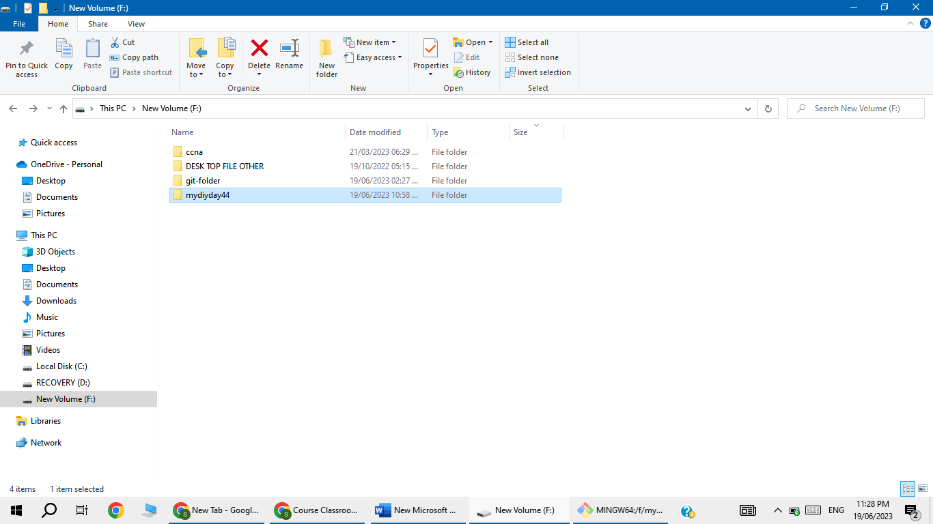

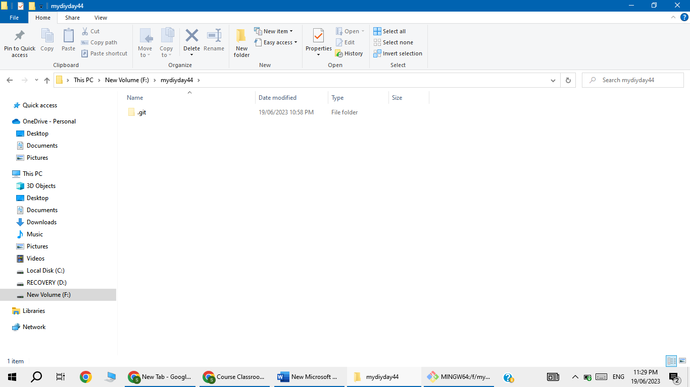

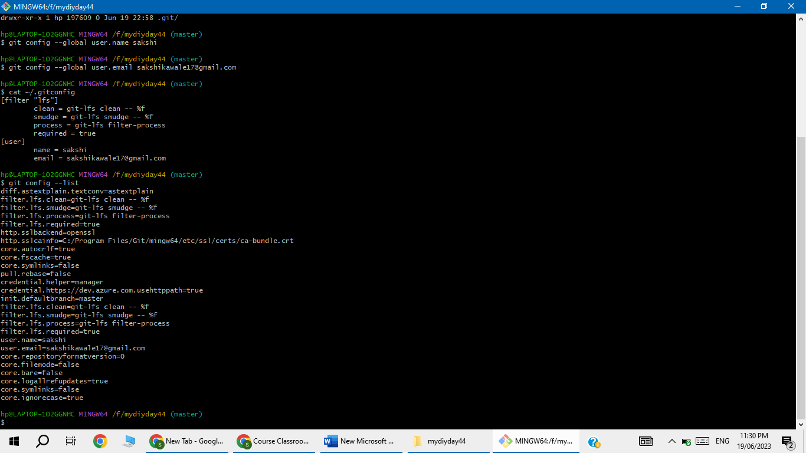

This gives list of all local , global and system configuration set on the current repository.

Now, delete the entry of created configurations

